**Weever Fish Stings: How to Avoid Them & How to Treat**

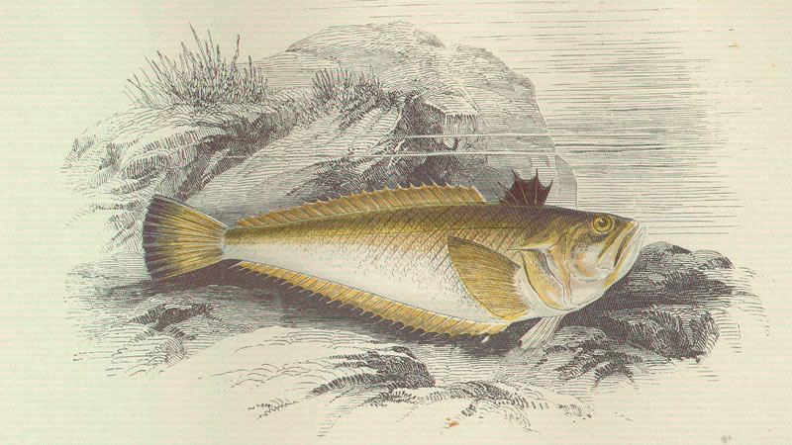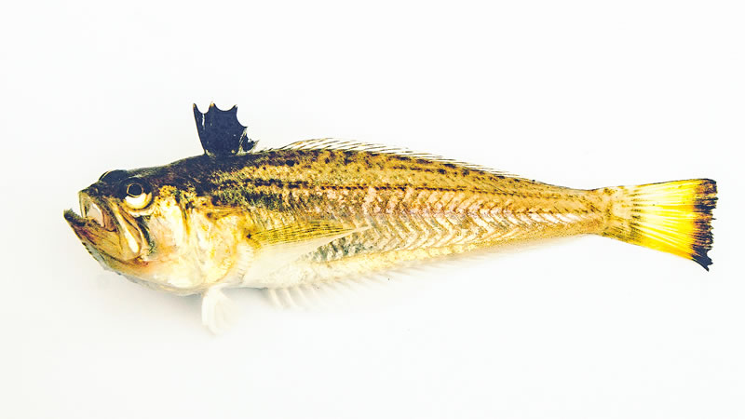

These little nippers are quite common in British waters, and although their stings can be painful, they’re not dangerous.

Here’s everything you need to know about weever fish from what they are to how to avoid being stung, and most importantly, how to treat annoying stings. **They make appearances all over Tiree but can be seen quite commonly on Balevullin beach and other beaches with a similar current and sand structure.**

WHAT ARE WEEVER FISH?

Most weever fish are quite small but they are capable of being over 30cm in length. They can be found all over Europe and often make an appearance in both the North Sea and the East Atlantic Ocean and are therefore found in coastal waters all around the UK, including on Tiree.

Unlike other fish, they sink when they are not swimming and will spend most of their time living in the sand. They are also able to spend long periods of time outside the water and therefore can often be found anywhere along the beach.

HOW DO THEY STING?

If someone tells you about a fish that can sting then your first impression might be to think of the likes of a jellyfish or a stingray that enjoy shallow waters. Weever fish instead, are a lot harder to spot and inject their venom in a much different way.

They have spines along their back which are needle-sharp. As we mentioned before, they spend most of their time lying in the sand and therefore most stings come from people merely standing on them while they are not wearing shoes.

HOW TO TREAT A WEEVER FISH STING

Treatment of the sting is fairly simple and it’s important to initially find a source of hot water. The water needs to be as hot as you can bear, but still comfortable enough to place your feet into. This has been shown to reduce the effectiveness of the venom by breaking down its protein, and it helps to reduce spasms.

Unfortunately, there is no anti-venom for the toxin. It’s recommended to keep the small wound open and let it bleed out the venom. The blood loss won’t be high and this will help to clear your body of some of the toxins.

The worst of the pain generally happens around 30 minutes following the sting and then will gradually subside. In this time, it’s a good idea to take painkillers to get through this period but it shouldn’t be too painful for long.

As well as following the steps of the basic treatment as above, you want to make sure that there aren’t any of the fish’s spines still in the wound. Removing them with tweezers immediately is very important.

HOW PAINFUL IS A WEEVER FISH STING?

Most people compare it to a bee sting and say the most intense pain passes quickly.

Thankfully it’s not going to be life-threatening. There has only ever been one recorded death and that happened in 1933 due to a vast number of stings.

Common symptoms include swelling, itching, numbness, headaches, joint aches, and occasionally vomiting. If more serious symptoms are presented, like breathing difficulties, then seek emergency help, especially for people who are susceptible to allergies.

How cAN i AVOID BEING STUNG?

**One great way to avoid weever fish stings is to wear shoes**. There are plenty of water shoes out there which are suitable for a beach and/or diving and will help to block the spines form making contact with your foot. Although these can affect you’re swimming.

If you’re not wearing shoes and you’re walking through sand, then it’s a good idea to shuffle your feet. That way, you won’t be touching the spine of the fish and it will vastly reduce the chances of being stung.

Take care, but don’t worry too much

Weever fish aren’t something you should be too worried about. Serious symptoms are very rare and treatment can be delivered quickly. You need to be mindful of them when you’re at a beach, but they shouldn’t stop you enjoying the water.

The bumblebee can sting us too, but that doesn’t make us avoid the countryside. So you shouldn’t let a little weever fish stop you going in the ocean either.